Premium Income Investor Letter 2/12/24

Hello Premium Income Investors,

The goal of a premium income trade is to collect a premium by selling a naked Put.

You can sell a naked Put on margin or cash secured. Both are good.

The margin requirement is only around 20% so if you use margin, your yield will be higher because you are using less cash to make the trade.

There is never a rush to get into this trade.

This week I like a premium income trade in Fortinet, FTNT.

FTNT is trading at 70.54 as I write this.

You can Sell to Open FTNT, Mar. 28, 66 strike price Puts for 1.07. This trade pays you $107.00 cash per option contract and lasts 45 days.

You can do this on margin or in a cash account if you don’t want to use margin.

If you want a higher premium use Puts with strike prices closer to the market price of the stock.

You can check the yield with the premium income calculator in the members area.
Here is how this trade looks in the calculator…

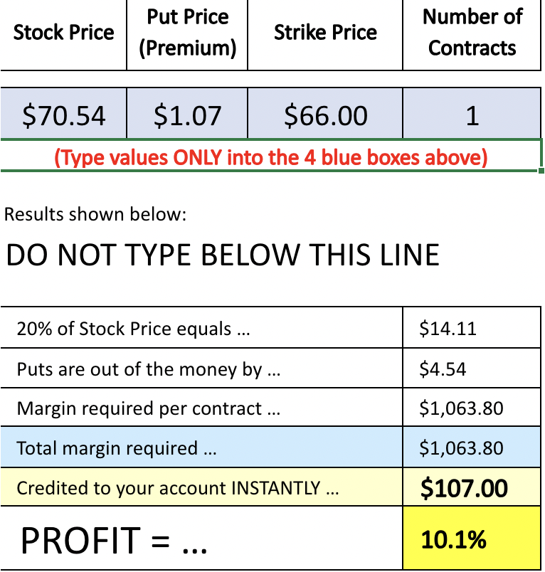

You can get out of this trade anytime by entering an order to Buy-To-Close the Puts you sold.

Goal: Let the options expire worthless. If the stock is above the strike price at expiration, the options will expire worthless, and you keep all the premium you received for selling the Put.

Exit Strategy A: Have the stock Put to you, then sell it and make a profit. If you get the stock Put to you, you can immediately sell the stock and still make a profit from the premium you received for selling the Put.

Exit Strategy B: Have the stock Put to you and keep it. Some people want the stock to be “Put” to them. If you get the stock, you can sell covered calls against it and bring in even more cash.

If you want the stock assigned to you at the strike, consider using a higher strike price. You get a higher premium, and you get a better chance of owning the stock at a great price.

Exit Strategy C: Get out before the stock hits your strike price. If you do not want the stock Put to you, set a conditional order to buy to close the option when the stock hits a price that is 1.00 above your strike price.

Trade Well,

Jack

